2024 International Day of Peace Speaker Bios

Keynote Speaker – Lewis Cardinal
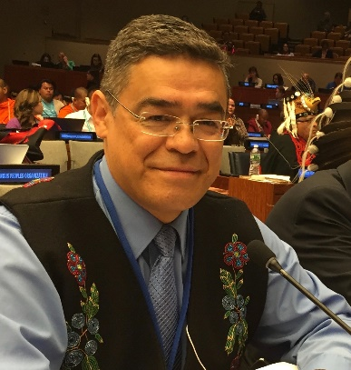
Lewis Cardinal is a communicator and educator. Lewis has dedicated his life’s work to creating and maintaining connections and relationships that cross-cultural divides. His long track record of local and international public service currently includes: Chair of Global Indigenous Dialogue of Initiatives of Change-International, Co-Chair of Initiatives of Change-Canada, Trustee and Executive Committee Member for the Parliament of the World’s Religions, and Honorary Board Member, Board of Sponsors, Martin Luther King Jr., International College of Ministers and Laity at Morehouse College in Atlanta, USA.
Lewis has received two medals from Queen Elizabeth II, the Diamond Jubilee Medal for Public Service and the Platinum Jubilee Medal for his contributions to the Province of Alberta, Canada. As well as, the IndSpire Award for Public Service (awarded by Indigenous peoples of Canada), the Treaty No. 8 Medal for the preservation and protection of Treaty Rights, the Province of Alberta’s Centennial Medal for his work in Human Rights and Diversity. Lewis has also received the Distinguished Alumni Award from MacEwan University, an Honorary Diploma for Indigenous Voice in Leadership from Norquest College, and the Honorary Degree of “Doctor of Sacred Letters” from St. Stephen’s College at the University of Alberta in Edmonton Alberta, Canada. And has been listed in Canada’s Who’s Who since 2014.
Lewis is Woodland Cree from the Sucker Creek Cree First Nation in Treaty No. 8 in northern Alberta, Canada. His consulting company, Cardinal Strategic Communications, specializes in Indigenous education, communications, and project development. He is also owner, CEO, and Head Storyteller of Red Earth Blue Sky Productions, a media productions company. Currently, Lewis is Senior Advisor for “kihcihkaw askî–Sacred Land” in the City of Edmonton, the first designated urban Indigenous ceremony grounds in Canada.
Panelists In Speaking Order
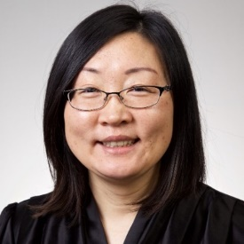
- Lidia Li, Buddhist
Lidia Li is the founder of the Central Alberta Chinese Culture Centre (CACCC). Lidia's commitment to cultural preservation and education extends beyond the Centre, as she actively organizes cultural activities and events in local schools, fostering a deeper understanding and appreciation of Chinese culture within the broader community.
Lidia also serves as the principal of the Red Deer Chinese School, where she is dedicated to providing high-quality education and cultural enrichment to students. Her previous experience as a Service Delivery Manager at the Central Bank of Alberta Credit Unions helped her develop the leadership and organizational skills that now benefit her community-driven initiatives.
Buddhism, deeply rooted in Chinese culture, plays a significant role in Lidia's life. She embraced Buddhism in 2019, and its teachings have profoundly influenced her worldview. Practices such as meditation, mindfulness, and the principles of compassion and non-attachment guide her daily routines, decision-making, and interactions with others, shaping both her personal and professional life.
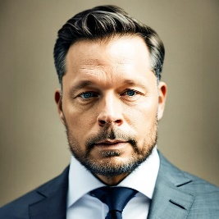
- Dr. Jonathon Penny, Humanist
Dr. Jonathon Penny serves as Dean of the School of Arts and Education at Red Deer Polytechnic and is deeply committed to promoting and magnifying the value and impact of the humanities, social sciences, and creative arts through education, civic engagement, and social and cultural enterprise. A longtime religionist, he withdrew from congregational faith in 2019 following an extended period of re-evaluation and now navigates the big (and small) questions as a secular humanist, valuing and championing the human potential for and practice of the good, and advocating for rational, ethical, and people-centered decision-making and behaviour.
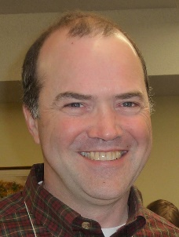
- Ross Smillie, Christian
Ross Smillie is a retired minister with the United Church of Canada who worked most recently in Red Deer and Lacombe. He has degrees in biochemistry, theology, and environmental ethics and is the author of two books (so far). But his greatest accomplishments (and joys) are as Poppa to two beautiful granddaughters.

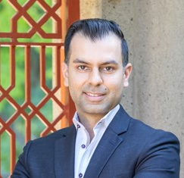
- Dr. Aman Haji, Muslim
Dr Aman Haji has been an educator within the Shi’a Isma’ili Muslim community for over 20 years. He has spoken about topics pertaining to Islam across Canada and internationally. Dr Haji has a broad educational background which includes studies in psychology, health promotion, chiropractic, acupuncture, law and bioethics, and medicine. Dr Haji is a practicing physician in Alberta and British Columbia with a focus on Primary Care and Addiction Medicine. He is a Clinical Assistant Professor in the Departments of Family Medicine at the University of British Columbia and the University of Calgary.

- Dr. Sylvia Kaye, Baha’i
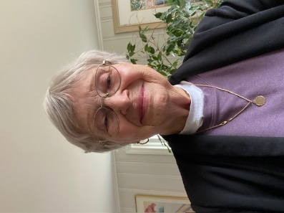
Dr. Sylvia Kaye moved to Canada this year, previously a resident of Botswana and South Africa. She obtained a PhD in Economic and Community Development with a focus on women entrepreneurs. In South Africa, together with a colleague, she developed a graduate peace studies and conflict transformation program at the Durban University of Technology. She taught graduate courses on peace theories and research methodology and supervised students up to the PhD level. Students were from African countries. The program included a focus on conflict transformation at a community level and on the concept of participatory action research as essential in research. The PhD graduates from the program continue to contribute to peace in their home countries.
She is a member of the Bahá’í Faith and has served in a variety of administrative contexts at the national and local levels. The Bahá’í Faith has as its core vision the unity of humanity, and that peace is not only possible, but inevitable as humanity adopts spiritual and practical solutions to its problems. As a member of the Bahá’í Faith, she has tried to contribute to this vision formally and informally, and continues to offer services to the community.

